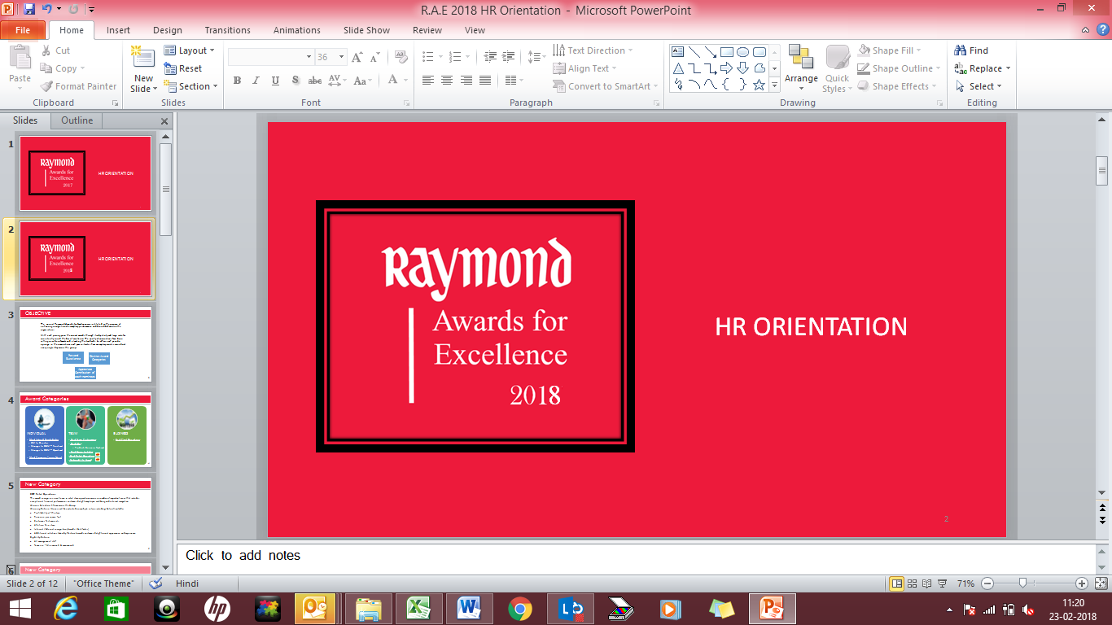

Idea of the Year

Nomination Form

Guidelines:

- Please complete this form and submit with any relevant supporting documents to your respective SBU Head (President) along with a copy to awards@raymond.in
- Please attach passport size photographs of members along with the updated nomination form.
- Submit any documents/pictures that you think would build a strong case for this nomination.
- The Awards Committee may contact you to collect additional details, if necessary.
- Mention the subject line as ‘Idea of the Year – (Category of the Idea)” (Product or design Innovation / Business Innovation / Process Innovation )when submitting your nomination

Eligibility Criteria
  - All management staff
  - Team size - Minimum 3 & maximum 6

- Winning Criteria: Winners will be judged on multiple criteria including, but not limited to:
  - Predictive longevity of the idea / Sustainability
  - Originality and Uniqueness of an Idea (Compared to internal and external benchmarks)
  - ROI / Level of impact (quantitative and qualitative) of the idea implemented to the business / function
  - Complexity/magnitude of implementation
  - Any other accomplishments through application of idea

NOMINATOR DETAILS
Name
Business |  |  |  |  | Location
Phone |  |  |  |  | Designation
About the Initiative
Title
Idea Category |  | Operational/ Functional Excellence  Design / Product Innovation  Business Innovation
Implemented at (Department/ Business/ Location):
Idea generated in (month and Year)
Implementation Period referred (Month & Year)
Synopsis of the Initiative (Summarize the Initiative in 2-3 lines)
NOMINEE DETAILS
Emp ID | Emp Name |  | Designation |  |  | Department |  | Phone No. / Mail ID
Objective – What business need triggered this initiative? Describe the business problem/ opportunity that was impacted by this
Describe the Initiative / Idea. (Assume the reader isn’t aware of the background.)
Implementation – Describe the process (development, research, challenges, and implementation). Was an external partner involved with the strategy or execution of the initiative? If yes, who was the partner?
Uniqueness – Describe what is unique about this idea?
Visible Impact – Describe the early success indicators and future potential impact.

As far as possible, provide robust quantifiable parameters that measure impact or ROI. This will clearly help identify outstanding contribution. Some illustrations on measureable parameters could be:
i. Reduction in the total cycle time/ lead time
ii. Cost containment, savings or reduction
iii. Reduction in percentage errors
iv. Customer feedback
Future Plans – Describe the way forward on this initiative. Can this initiative be amplified? If yes, where and to what extent?

Thank You

